G’day,

We have just gotten back from our trip which took us from Brisbane to Thargomindah, Innamincka, Lyndhurst ( caught the last day the Farina bakery was open with the baker being an Birdwood boy), Maree, William Creek, Coober Pedy for a couple of night underground in the Comfort Inn. There we met up with another OKA couple Deano and Kaye who joined us essentially for the rest of our trip, the Anne Beadell to Laverton with a side trip on the Centre Line track via the 250 mile maker to Dingo Clay pan, back to Emu and onto Laverton.

Thought you might be interested in the Centre Line as it is probably Lens least known track, cut in 1951, it is the line of fire from the launch pad in Woomera to a mid-point on Eighty Mile Beach on the WA coast. He cut the track to mark the 250, 300, 350 etc where he pegged out a different canvas shapes at each marker so they could be identified from the air.

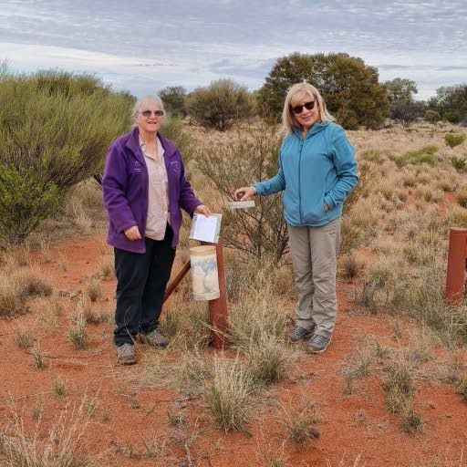

Wendy and Kay at the visitor message pipe.
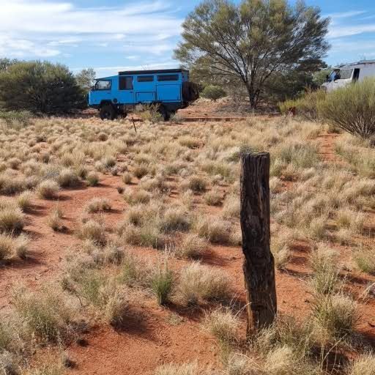

The original marker post is still there.

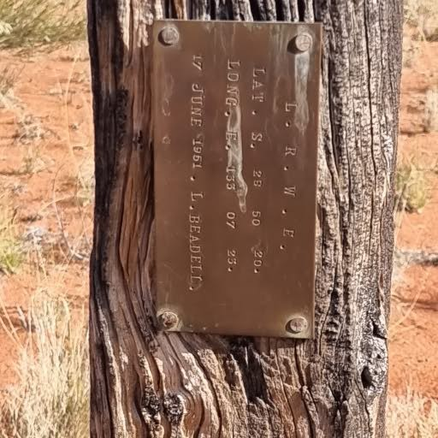

He original plaque

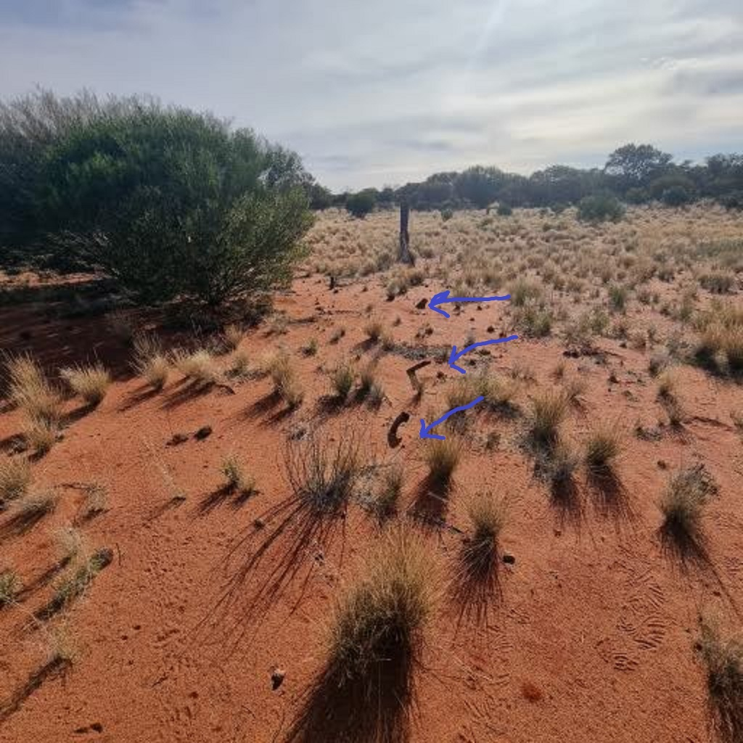

These are some of the original mallee stakes he used to stretch out the canvas. It is amazing that they are still there. Clearly visitors who manage to get to the 250 mile marker, respect the history.

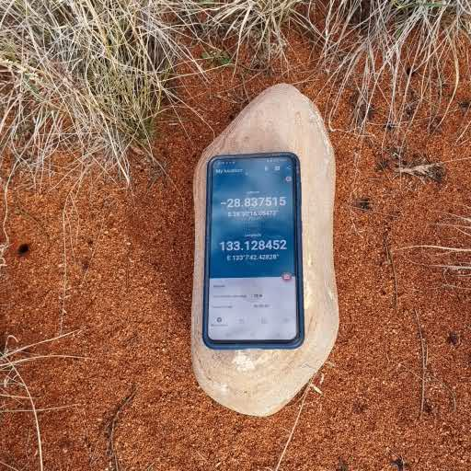
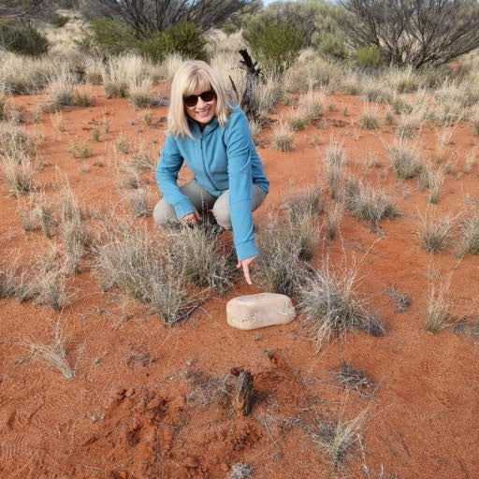

Len would set a position from the stars to determine his exact position and from there, determine the position of the 250 mile marker. This is the stone he used to mark the astrostation position. I found it on my prior trip, but Wendy’s I phone made finding it again much easier!!!
I did this track 10 years ago in our 110 Defender. It took me 2 days for the approx. 90km. When I got to the 250-mile marker on that trip, there had been a group in Land rover 7-8 months before me and then it was 7 years to the last person. This time there had been 3 there since my last trip and none in the last 8 years. So 5 people/groups have done it in the last 17 years. As a result, the trip was very very overgrown and, in many places, did not exist at all. Deano and I spent considerable time walking out to find the track, often just a raised line of dirt from where the grader made the original track.
This time it took 5 days with 1 day literally spent changing and repairing tyres.

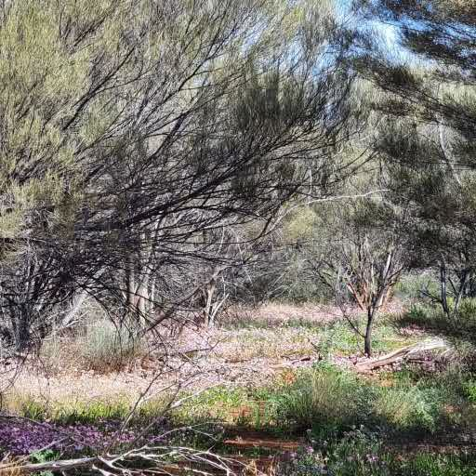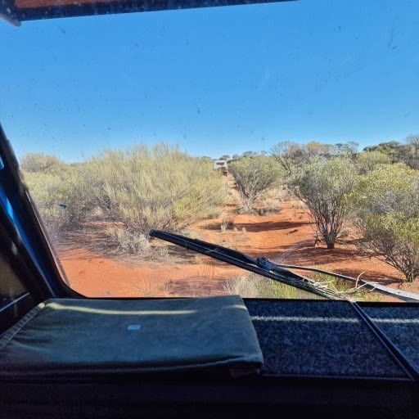
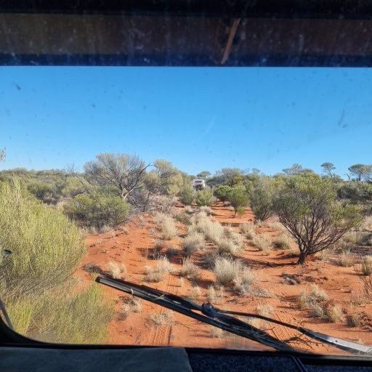

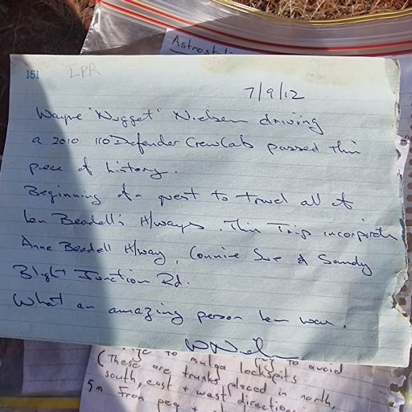

My note from the previous trip. I feel extremely honoured. Most people don’t get here once, and I have been twice!
This time it took 5 days with virtually 1 day spent on tyres.The trucks took a fair bashing with plenty of bush pinstriping as badges of honour, but it was the tyres which really coped it. Deano did 5 tyres and we did 2. One of Deano’s was a scrap job with a massive side wall stake, another had 3 sidewall stakes each requiring 5-6 plugs in each plus it had a couple of punctures in the tread area with that tyre having a total of 15-15 plugs. By the time we got to Dingo, Deano had 1 unscathed and I had 1 ruined and 1 with a slow leak which turned out to be a stake the size on my index finger. As my tyres fared better than Deano’s, Jake arranged for 6 new tyres to be sent from Brisbane to Kalgoorlie for us.

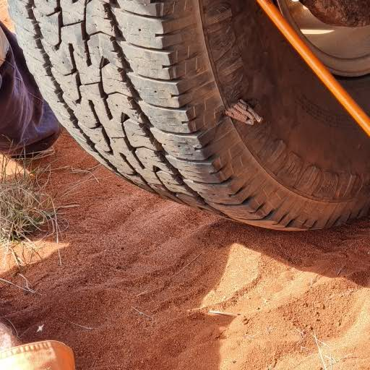
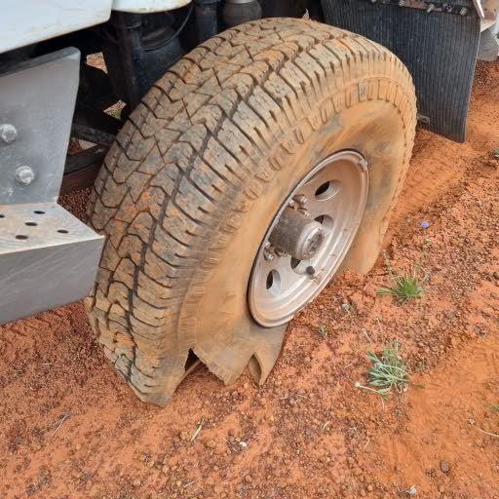

New meaning for ”Its only flat on the bottom”

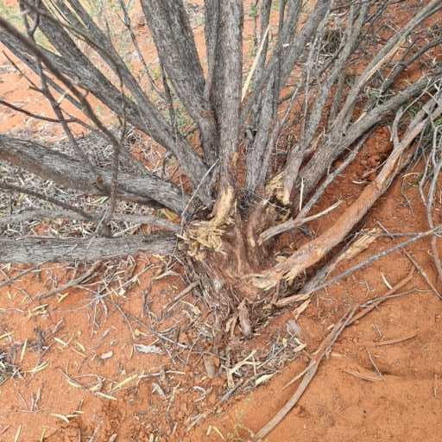

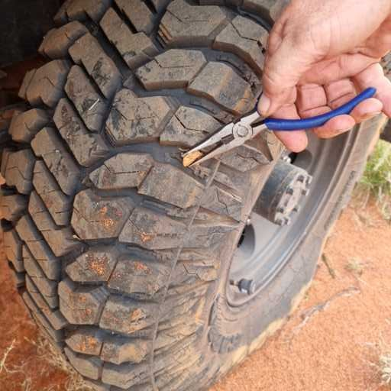
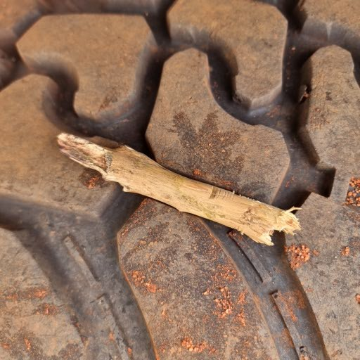

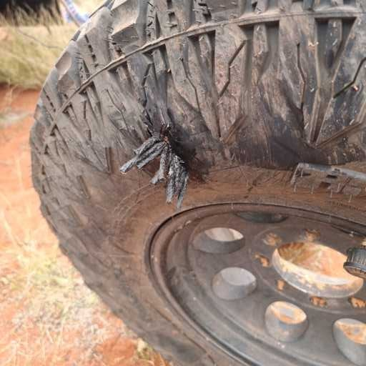

When this remote, you try to patch anything…well it was worth a try!

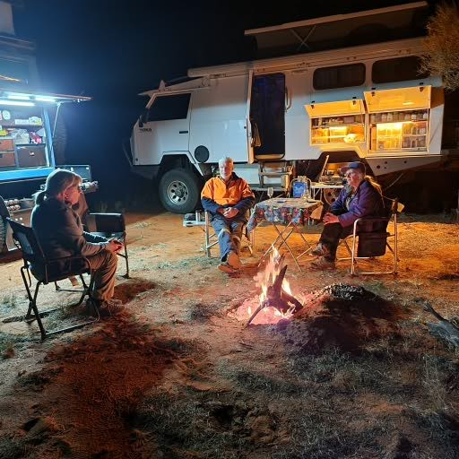

We had magnificent camp spots and campfires every night.

Last time doing the exact same trip took a total of 5 days. This time it took 13 days with much of it at 20-30kms/hr over some of the worst corrugations I have seen. Traditionally the Anne Beadell H/way is the original road from Mabel Station out of Coober Pedy all the way to Ilkurka, an aboriginal settlement over the WA boarder. The road was pretty much a graded good road from there which they tell me is graded every 5 years. I suspect it has been 4 years and 364 days sine the last grade as it was as bad as the rest all the way to about 60kms out of Laverton where a mining operation had commenced.

